MVP

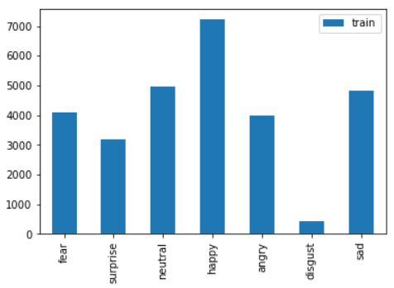

Fig 1: EDA for training set

This image shows our dataset based on its each Category, highest one is happy, following sad and so on.